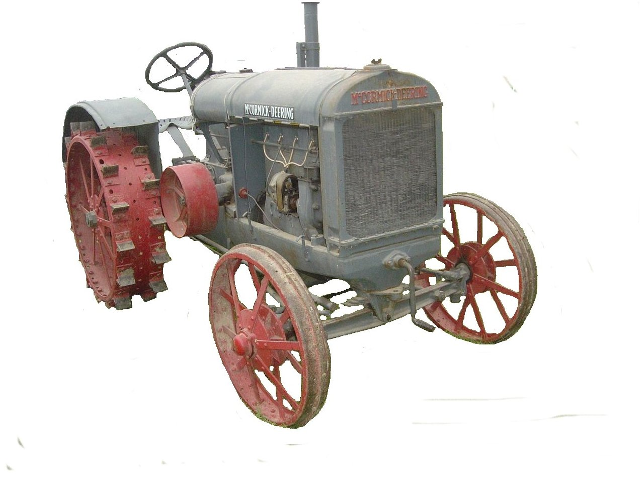
F O O T H I L L S

ANTIQUE POWER ASSOCIATION
ESTABLISHED 2003

Dear Members, September 2016
The fall season has officially begun: the fair is over, school has started, Labor Day has come and gone, and it is time to enjoy all the festivities, shows, and parades that the cooler weather brings. Hopefully each of you will have opportunity to participate in several events and represent our club in a favorable manner.

--- --- --- from the September meeting --- --- ---

- We continue to have quite a few members, friends, and family members on our prayer list. I’m sure there are several others whose names could be added, but these are the ones we have been informed of. Of course, we ought to pray for one another each day, not just because one or two of us has a special need, but because this world can be a rough place and it seems to be getting rougher by the minute. Let us not forget to pray.

  - Shirley Robinson
  - Timmy Jones
  - Ray Weaver
  - Doug Huffman
  - Cole Abernathy
  - Ann Little
  - Kenneth Beach
  - Powell Sigmon
  - Vee Williams

  - Larry Sigmon
  - Donnie Elmore
  - Linda Sigmon
  - Lorna Sheets
  - Billie Sue Goforth
  - Steve Hefner
  - Wade Hefner
  - Norris Turner
  - Terry Martin
  - Eugene Hartley
  - Ira & Ann Cline
  - Howard Cooper
  - Kelly Blanton
  - Dot Hawn
  - Rev. Bobby Langston
  - Allen Everdyke
  - Don Johnson
  - Carl Porter
  - Jane Abernathy

- September 17 is the Swap meet. Gates open at 6AM for sellers, 7AM for the public. Entry fee is $5 per person for all who come through the gate (12 & over).
  - So gather up your stuff and bring it to the fairgrounds that morning.
  - If you don’t have anything to sell, come looking to buy. Who knows, you might find that one thing you have been looking for.

- September 17 is also the Building Fund Raffle dinner at Bethel Lutheran Ch. Fellowship Hall.
  - This year we will be featuring Barbeque (all you can eat) and all the fixin’s and all is to be prepared by our members.
  - As for the desserts, we once again call upon our ladies (and those men so inclined) to prepare the dainty treats we have come to enjoy so much over the last several years.
  - A few tickets may still be available. Contact Ned Story, Wilson Sigmon, Tim Hollar, and a few others. They are $50 each, entitling the bearer to two meals and 1 chance in the drawing: the grand prize being $3000 cash.
  - We need some volunteers to help set up the night before (Sept 16 @ 6PM).

    - To get there from the Newton and Hickory areas, take NC 16 north. Turn left onto Oxford Sch. Rd, travel about 2 miles and turn left onto Riverbend Rd. Bethel will be on your right after about ½ mile.
    - From the Taylorsville area, travel NC 16 across the river, then turn left onto Oxford Sch Rd. Travel about 2 miles and turn left onto Riverbend Rd. Bethel will be on your right after about ½ mile.
    - From the Catawba & Claremont areas, travel Oxford Sch Rd north, turn right onto Riverbend Rd. Bethel will be on your right after about ½ mile.

- Our club outing is coming up on Saturday, October 1. Once again, Glenn Sigmon has graciously offered to provide us the privilege of gathering at his place on the river.
  - We ask everyone to arrive by 5:00 PM for the annual club photo and presentation of show proceeds to our charities, but all are encouraged to come as early as you can so we can enjoy a time of fellowship and enjoy the peacefulness of Glenn’s place. The evening dinner will begin at 6PM, but come early so we can enjoy some more fellowship together.
  - If you’ve never been there before, it is easy to find.
    - From NC16 about 2 miles south of Oxford Dam, turn east onto River Bend Road. Travel about 2 miles, then turn left (north) onto Hafer Rd. and go to the end of the road.
  - Glenn is such a wonderfully gracious host and we truly appreciate his willingness to share his home with all of us.
  - Glenn has also invited all who would like to come out on Friday evening (Sept 30) for a cookout. You can bring some of your equipment if you’d like and we’ll have our own private show.

- The upcoming October meeting (less than two months away) will feature the election of officers and board members. Anyone who is willing to serve in some capacity is asked to contact any of the current officers and board members. We really need some help we can count on when the time comes to get things done. Some of us are getting older and there will come a time when the younger members will need to step up to the plate. What better time to learn what is needed than now.

☺ ☺ !!!!! HAPPY BIRTHDAY !!!!! ☺ ☺

September birthdays


1 – Dylan Cabe
3 – James West
6 – Danny Miller
7 – Leon Baker
8 – Mike Grishaber

9 – Kelly Nash
12 – Danny Scarbro
12 – Gwynn Yount
13 – Patrick Hepburn
13 – Mark O. Sigmon
15 – Rachel Keller
16 – Tim Miller
18 – Kenneth Beach
22 – Bruce Long
23 – Clay Cannon
25 – Dawhite Moody


October birthdays

1 – Doug Carrigan
1 – Brian McIntosh
5 – Tim Hollar
5 – Richard Hudson

7 – David Setzer
8 – Bob Huffman
13 – Jeff Bowman
17 – Todd Painter
18 – Johnny Parsons
19 – Eugene Lefeber
19 – Tyler lutz
28 – Keith Beck
28 – Richard Drum

-- --- --- THE CLASSIFIEDS --- --- ---

Is there anything you would like to sell or are you looking for something special? List it here.
(Item listings will run for 3 months before expiring. Let us know when an item is sold or bought.)

FOR SALE WANTED

Farmall Super A, taking offers, Wilfred Parker, Old-style, 3-wheel hay rake,
(828) 428-9193 (16-06). Kermit Nash 828-312-2071 (16-07).

--- --- --- UP-COMING EVENTS --- --- ---

Sept 17 Newton FAPA Swap Meet
Sept 17 Bethel LC FAPA Raffle dinner
Sept 24-25 Catawba Murray’s Mill Festival
Sept30-Oct1 Morganton Valley Hills Show & Plow Day
Oct 1 Catfish Club outing at Glen Sigmon’s
Oct 6 Sig’s Monthly meeting – Elections
Oct 7-9 Dallas Cotton Ginning Days
Oct 14-16 Charlotte Stumptown Tractor Show
Oct 20-22 Arden WNC Fall Harvest Days
Oct 22 Statesville Clark’s Chapel B. Ch. Car/truck show
Nov 3 Sig’s Monthly meeting
Nov 4-6 Carthage 100+ Years of Progress show
Nov 26 Maiden Maiden Christmas parade
Dec 3 Taylorsville Taylorsville Christmas parad
Dec 3 Claremont Claremont Christmas parad

President: Kevin Black 828-464-1950 Vice Pres: Wilson Sigmon 828-256-2176
Treasurer: Kermit Nash 828-459-9616 Secretary: David Setzer 828-850-4943
Show Chair: Ned Story 828-464-6399 Asst. Show Chair: Teddy Hefner 828-310-5525
Asst. Secretary: Kevin Sigmon 828-256-21
--- --- --- something to think about --- --- ---

Recently, I had a conversation with one of our members. Though it was very short, it was very encouraging to both of us. It was not a conversation like millions occurring everyday about the weather, or politics, or sports, or what so-and-so did. It was about life and it was about our Lord and our God.
There is nothing wrong with discussing the issues of the day, but rarely in those talks is there any exhortation, encouragement, and even more rarely any comfort. For the overwhelming majority of men and women in this world and a very significant number of Christians, the words they speak and hear fall into this category. They may enjoy the topic of conversation, they may learn something useful, or they may become anxious or worried as a result, but rarely are they encouraged or comforted. Why?
True encouragement and true comfort come through the interaction between two people only if a third person is with them. That third person is Christ Jesus the Lord of glory. If Christ is present, there will be encouragement, there will be exhortation, there will be comfort, there may even be conviction (but that will always be followed by comfort and exhortation).
We say (and rightly so as Christians) that he is in us, but can we, with equal certainty, say that we are in him? We can if we are consciously aware of what he has done for us and what God has made us to be through him. This is more than saying “I am saved,” more than saying “I am going to heaven,” more than saying “I go to church every Sunday.” It is the uniquely personal knowing that you stand in this world, at this moment in time, as the visible and audible expression of Christ himself. That is incredible to consider, but it is what God has made us to be. It is not our doing, nor is it because of any schooling we have received, it is God’s doing! The question is: will we actually live that life, or will we continue living what we have been?
One-way conversation from the preacher to the congregation on Sunday morning is needful, but it is not near enough. We each need one-on-one interaction with our Lord and God via prayer and reading The Word, and we need one-on-one interaction amongst each other every day, sometimes several times in a day. Our Lord said “where two or three are gathered together in my name, there am I.” If this is true (and it is, anywhere, anytime) do we believe it and acknowledge his presence, or do we ignore him as though he does not exist?
If we are living every day by faith (the conscious acknowledgement of and active reliance upon Christ Jesus’ complete work for us and in us as revealed by The Word of God and the spirit of God in us), the words we speak will encourage, exhort, and comfort those who hear. If our faith is lacking – if it is not presently active in our minds and in our hearts – our words will be very much as those of a rank unbeliever, accomplishing, at best, little of value and, at worst, tearing down instead of building up.

God bless you all.
See you in October.
Your Secretary, David Setzer

